<!DOCTYPE html>

<html>

<head>

<title>Ayush Rawat MCA-B 26</title>

</head>

<body>

<table border="1" cellspacing="0" cellpadding="7">

<tr align="center">

<td rowspan="2" colspan="2"><strong>CI</strong></td>

<td rowspan="2"><strong>All<br>Genders</strong></td>

<td><strong>By Gender</strong></td>

</tr>

<tr>

<td>

<table border="1" cellpadding="4">

<tr align=center>

<td><strong>Males</strong></td>

<td><strong>Females</strong></td>

</tr>

<tr>

<td>9215604

<td>4512358</td>

</tr>

</table>

</td>

</tr>

<tr align="center">

<td><strong>Rural</strong></td>

<td>6521458</td>

<td>4215389</td>

<td>4152348</td>

</tr>

</table>

<br><br><br><br>

<table border="1" cellspacing="0">

<tr bgcolor="yellow">

<td align="center" colspan="6"><strong>Time Table</strong></td>

</tr>

<tr>

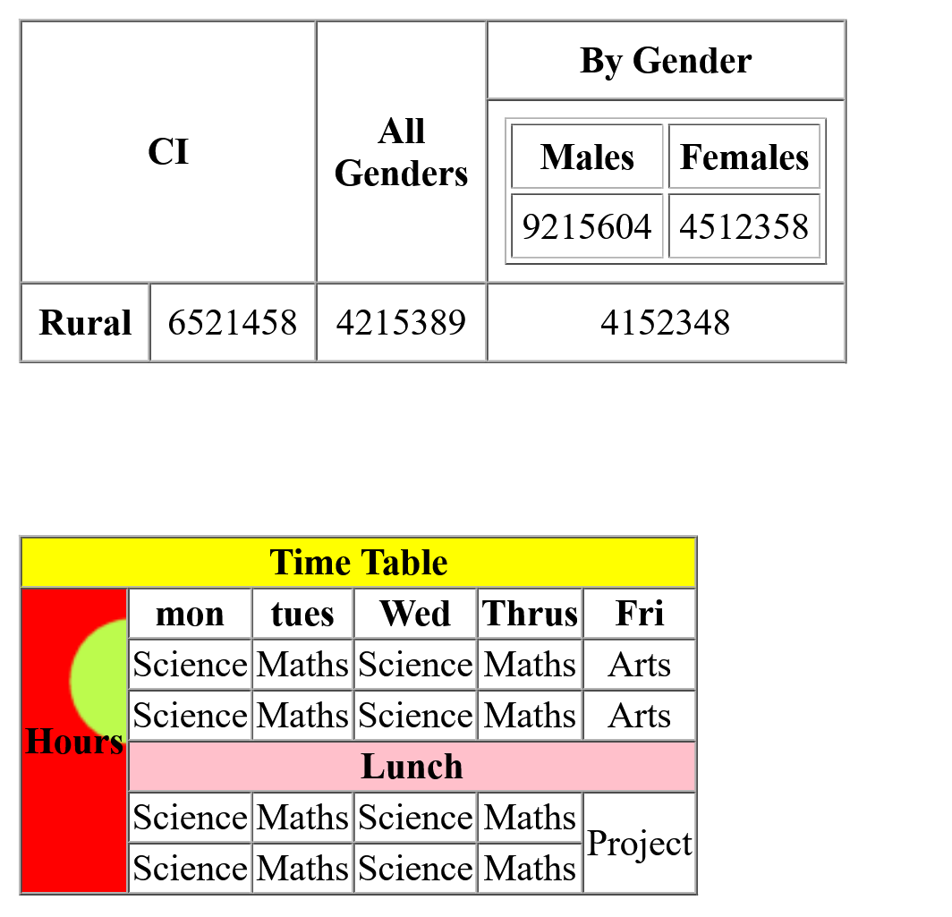

<td align="center" rowspan="6" background="polygon-1.png"> <strong>Hours<strong></td>

<td align="center"><strong>mon<strong></td>

<td align="center"><strong>tues<strong></td>

<td align="center"><strong>Wed<strong></td>

<td align="center"><strong>Thrus<strong></td>

<td align="center"><strong>Fri<strong></td>

</tr>

<tr>

<td align="center">Science</td>

<td align="center">Maths</td>

<td align="center">Science</td>

<td align="center">Maths</td>

<td align="center">Arts</td>

</tr>

<tr>

<td align="center">Science</td>

<td align="center">Maths</td>

<td align="center">Science</td>

<td align="center">Maths</td>

<td align="center">Arts</td>

</tr>

<tr bgcolor="pink">

<td align="center" colspan="5"><strong>Lunch</strong></td>

</tr>

<tr>

<td align="center">Science</td>

<td align="center">Maths</td>

<td align="center">Science</td>

<td align="center">Maths</td>

<td align="center" rowspan="2">Project</td>

</tr>

<tr>

<td align="center">Science</td>

<td align="center">Maths</td>

<td align="center">Science</td>

<td align="center">Maths</td>

</tr>

</table>

</body>

</html>